Tarea: Escribe el ARTÍCULO INDEFINIDO Y DEFINIDO
MODELO:
__________________ o _______________________
El chico
Un chico
1. 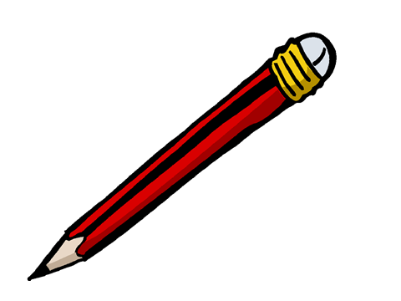____________________________ o ______________________________
2. ____________________________ o ______________________________
3. 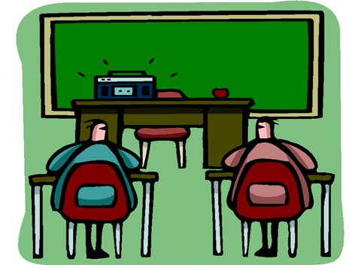____________________________ o ______________________________
4. ____________________________ o ______________________________
5. ____________________________ o ______________________________

Más
6. 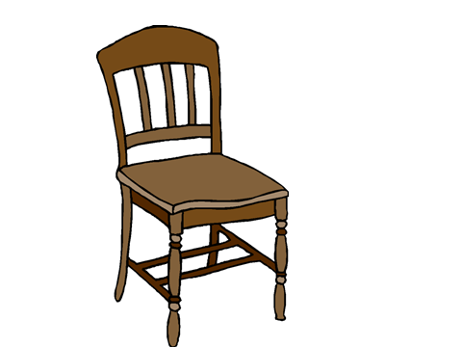____________________________ o ______________________________
7. 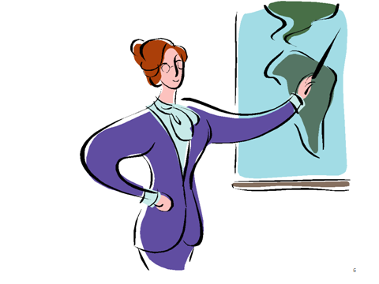____________________________ o ______________________________
8. 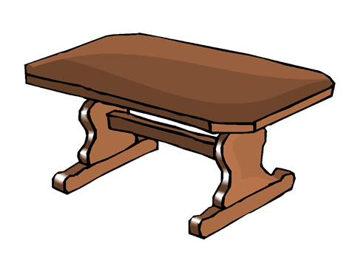____________________________ o ______________________________
9. ____________________________ o ______________________________
10. 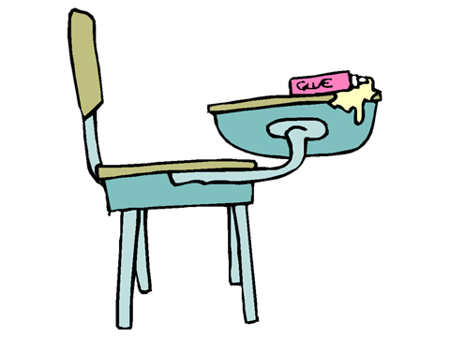____________________________ o ______________________________
11. 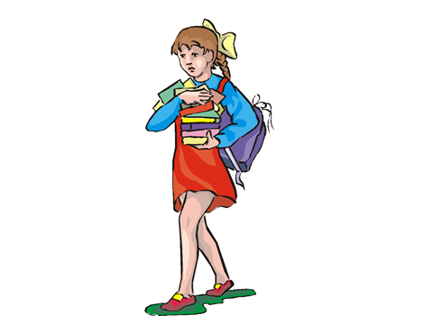____________________________ o ______________________________

