Español 1 Día de Los Muertos

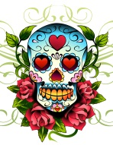**Día de Los Muertos: Cuatro escenas**

(Fecha de entrega:___________)

**Objective:** In groups of four students, your group must create a 3D pyramid like structure, in which four of the main components of the Hispanic cultural celebration of ***El Día de Los Muertos*** are depicted. You must also label a variety of products or practices related to each individual element within the structure.

**C:\Users\aisern\AppData\Local\Microsoft\Windows\Temporary Internet Files\Content.IE5\010EP9JD\MC900338328[1].wmfC:\Users\aisern\AppData\Local\Microsoft\Windows\Temporary Internet Files\Content.IE5\010EP9JD\MC900098075[1].wmfThe four components are:**

1. El altar
2. El panteón / el cementerio
3. La procesión
4. Escena de Calacas

**Materials:**

The main structure: Cardstock will be used to create all four individual structures which will be glued together to create the final 3D pyramid like structure.

Depiction of products and practices for each individual structure: Students can bring materials from home if they please in order to create a 3D depiction of each component of the celebration. Students may also use cardstock or construction paper from school. (Suggestion of things to bring: beads, real objects, dry food, small rocks, small old toys… be creative).

**Vocabulary- Aside from each section having the title of what component it is depicting, you must also include a minimum of 15 words from the following vocabulary list, within the entire project, as well as five other words you find on your own. Make sure to place the correct words where they belong.**

1. **La ofrenda**
2. **El copal**
3. **Las velas**
4. **Las flores-el cempaxúchitl**
5. **Los pétalos**
6. **La cruz**
7. **La tumba**
8. **El papel picado**
9. **El pan de muerto**
10. **La calavera de azúcar – las calaveritas**
11. **Objetos religiosos**
12. **Las fotos**
13. **La fruta**
14. **El agua**
15. **La sal**
16. **Las comidas y bebidas favoritas**
17. **La máscara**
18. **Las personas**
19. **El desfile**
20. **Las calacas**
21. **El esqueleto**
22. **La catrina**
23. **La muerte**
24. **La vida**
25. **El disfraz**
26. **Las coronas de flores**
27. **El mole**
28. **Los huesos**
29. **El espíritu**
30. **La mariposa**

**Somewhere on the structure you must include the name of the cultural celebration and the date it takes place.**

**The structure must have the names of all students in the group, and the period on the bottom of the base. So make sure to label your portion with a marker and make sure it is legible.**

**Suggestion: Each student should be in charge of doing one scene or one aspect of the construction.**

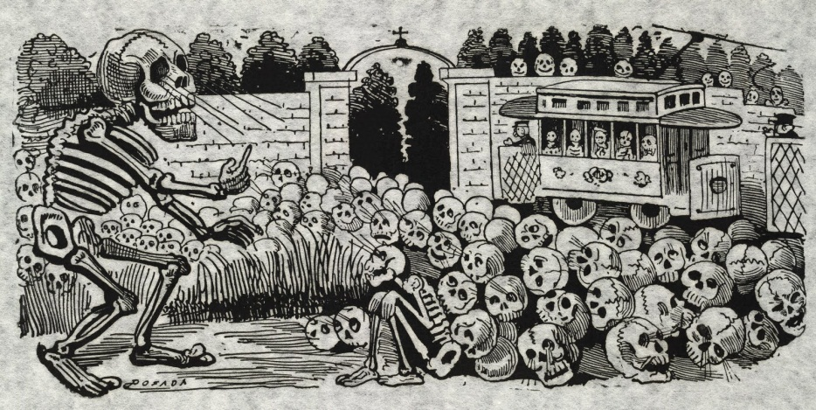

**C:\Users\aisern\AppData\Local\Microsoft\Windows\Temporary Internet Files\Content.IE5\010EP9JD\MC900283121[1].wmfC:\Users\aisern\AppData\Local\Microsoft\Windows\Temporary Internet Files\Content.IE5\HVK8985B\MC900183542[1].wmf**