¿Cómo son tus clases?
Evaluación interpersonal

With a partner, you will greet and discuss your school schedule in front of the teacher.
- You will draw a number out of a hat that represents the class period you must discuss. Therefore, you must be prepared to discuss all of your classes
- You can use pictures from the question cards we practice with, but you may not use notes.
- In addition, you must discuss another aspect of your schedule from a drawn card: what you do at lunch, after school (después de la escuela), or what you favorite or least favorite class is.
Review the rubric on the back and remember that your evaluation is based on:
- your variety of vocabulary
- your sentence structure
- how well you are understood
- how well you understand
- to what degree your errors affect your communication
- your completion of the task

Fecha de evaluación interpersonal: __________________________________________

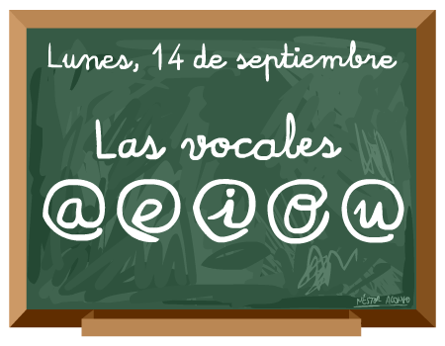

Criterio de evaluación: Nombre: _________________________________________
¿Cómo son tus clases?, Español 1 Clase/Hora:_____________ Fecha: ___________________
MAJOR FOCUS
Proficiency levels | Novice  Low | Novice  Mid | Novice  High | Intermediate  Low
What language do I use?  Vocabulario | I can use a small number of repetitive words and phrases for common objects and actions. | limited words and phrases  common subjects  repetition | familiar words and phrases  some elaboration, opinion | variety of words and phrases on range of familiar topics  begin to give details and elaborate
How do I use language?  Estructura | I can use some simple words to provide basic information. | words  phrases  simple sentences | phrases  original sentences | strings of sentences to express thoughts
How well am I understood during task?  Comprensibilidad | I can be understood only with great effort. | understood with difficulty by those accustomed to learner | mostly understood by those accustomed to learner | understood by those accustomed to learner
How well do I understand?  Comprensión (only Interpersonal task) | understand some isolated words | understand some simple questions and statements  frequently need to hear things again | understand simple questions and statements  sometimes I need to hear things again | understand questions and statements  sometimes I need to hear things again

MINOR FOCUS
How well do I use the language?  Language control | my errors prevent communication | my errors sometimes prevent communication | my errors do not prevent communication | few to no errors
How much language did I deliver?  Task completion | little of task complete | most of task complete | task complete | went above task

Más comentarios:

