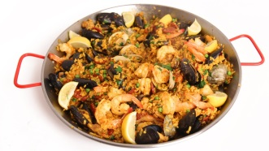
¡Qué Sabroso!
Proyecto: Platos típicos del mundo hispanohablante
Objetivo: Get to know various foods from the Spanish-Speaking world and describe them using vocabulary from our Comida unit. Due ___________________________
¿Cómo?
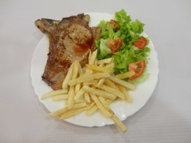
Alone or with a partner, research a typical food or drink from one country in the Spanish Speaking world and present it to a group of students in the class as a poster or Power Point presentation.
Incluye:
A. ¿Cómo se llama el plato y de dónde es?

B. ¿Qué ingredientes tiene? (if it is a word we haven´t studied, show a picture of it in your visual)

C. ¿Cómo / o Cuándo / o Dónde comen las personas la comida? (con otra comida, durante el desayuno/almuerzo/cena/merienda/postre, en casa/restaurante/fiestas/ocasiones especiales/Navidad).

D. ¿Cómo es? ¿Es similar a un plato americano? ¿Es bueno o malo para la salud? ¿Es Sabroso, picante, dulce, etc.?

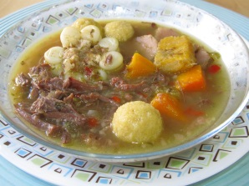
E. ¿Te gusta? o ¿Crees que te gustaría? (¿Think you would like it?) ¿Por qué?

La búsqueda:
- Have your country of choice approved by ____________
- You must use at least two sites with at least one in Spanish
- Start your search in Spanish. Print out the Spanish site and highlight words you know.
- Fill this notes sheet as evidence of your research/tarea credit
Some search terms to use are:

No puedes usar un plato familiar, como ¨enchiladas¨. Necesitas aprender algo nuevo (learn something new)!
Criterio de evaluación: Nombre: _________________________________________
Plato Típico Hispano, Español 1 Clase/Hora:_____________ Fecha: ___________________
MAJOR FOCUS
Proficiency levels | Novice  Low | Novice  Mid | Novice  High | Intermediate  Low
What language do I use?  Vocabulario | I can use a small number of repetitive words and phrases for common objects and actions. | limited words and phrases  common subjects  repetition | familiar words and phrases  some elaboration, opinion | variety of words and phrases on range of familiar topics  begin to give details and elaborate
How do I use language?  Estructura | I can use some simple words to provide basic information. | words  phrases  simple sentences | phrases  original sentences | strings of sentences to express thoughts
How well am I understood during task?  Comprensibilidad | I can be understood only with great effort. | understood with difficulty by those accustomed to learner | mostly understood by those accustomed to learner | understood by those accustomed to learner
How well do I understand?  Comprensión (only Interpersonal task) | understand some isolated words | understand some simple questions and statements  frequently need to hear things again | understand simple questions and statements  sometimes I need to hear things again | understand questions and statements  sometimes I need to hear things again

MINOR FOCUS
How well do I use the language?  Language control | my errors prevent communication | my errors sometimes prevent communication | my errors do not prevent communication | few to no errors
How much language did I deliver?  Task completion | little of task complete | most of task complete | task complete | went above task

Más comentarios:

