Una persona importante en mi vida
“Tú eres famoso…según yo”
Presentación escrita

People en español is calling for nominations of ordinary people who make their mark in the world without being famous. For Christmas, since you don’t have much money this year, you’d like to nominate someone important in your life. The winner receives a special gift for their “persona importante.” Describe this person by writing a letter, poem, or song.

- Introduce yourself
- Introduce the person you are describing, what your relationship is.
- Describe what he/she looks like. Then, describe his/her personality.
- Don’t forget to use adjective agreement.
- Your presentation should include a variety of vocabulary, including “las palabras importantes” (important words and expressions). A veces, siempre, un poco, muy, según, también, tampoco, pero, con.
- Include a few other descriptions from semester 1 in 3rd person.
- Include a visual representation—a photo, your drawing or painting, or symbols which describes who they are.
- Type or neatly write on plain paper, including accent marks.
- The strongest pieces will be displayed at Inspire’s Gala on Jan. 12.

Fecha de entrega/due date: ___________________________________

Worth 30 points. Rubric on back.

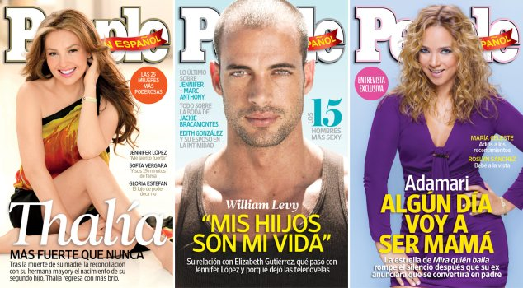
Criterio de evaluación / rubric
MAJOR FOCUS your goal!
PROFICIENCY LEVELS | Novice  Low | Novice  Mid | Novice  High
What language do I use?  Vocabulario | I can use a small number of repetitive words and phrases for common objects and actions. | I can use a limited number of words and phrases for common objects and actions, but they are repetitive. | I can use familiar words and phrases on familiar tasks, topics, and activities. I can elaborate a little.
How do I use language?  Estructura | I can use some simple words to provide basic information. | I can use words, phrases, and occasional sentences to provide basic information. | I can use phrases and short simple sentences to provide basic information. I can begin to combine words and phrases to create original sentences.
How well am I understood?  Comprensibilidad | I can be understood only with great effort. | I can be understood with difficulty by someone accustomed to a language learner. | I can mostly be understood by someone accustomed to a language learner.

MINOR FOCUS
How well do I use the language?  Language control | My errors in grammar, word order, and word choice prevent communication. | My errors in grammar, word order, and word choice sometimes prevent communication. | My errors in grammar, word order and word choice do not prevent communication. | I don’t make any errors in grammar, word order, or word choice that prevent communication.
How much language did I deliver?  Task completion | I completed little of what I was asked to do. | I completed most everything I was asked to do. | I completed everything I was asked to do. | I completed more than I was asked to do.

Más comentarios:

